Greenfield Build Cost Comparison
1016 SW Evangeline Thruway, Lafayette, LA 70501
Prepared May 30, 2026 | Order-of-magnitude budgeting memo
Bottom line: A greenfield replacement of the existing +/-173,437 SF dry warehouse/distribution facility on a +/-12.26-acre industrial site is likely a $19,427,681 to $26,601,491 all-in project including land, or roughly $112.02/SF to $153.38/SF of building area. Excluding land, the build budget is roughly $18,427,681 to $24,801,491. The current $6.0M asking price equates to about $34.59/SF, but the offering appears to be leasehold improvements only under a ground lease, so fee-simple economics are not apples-to-apples.
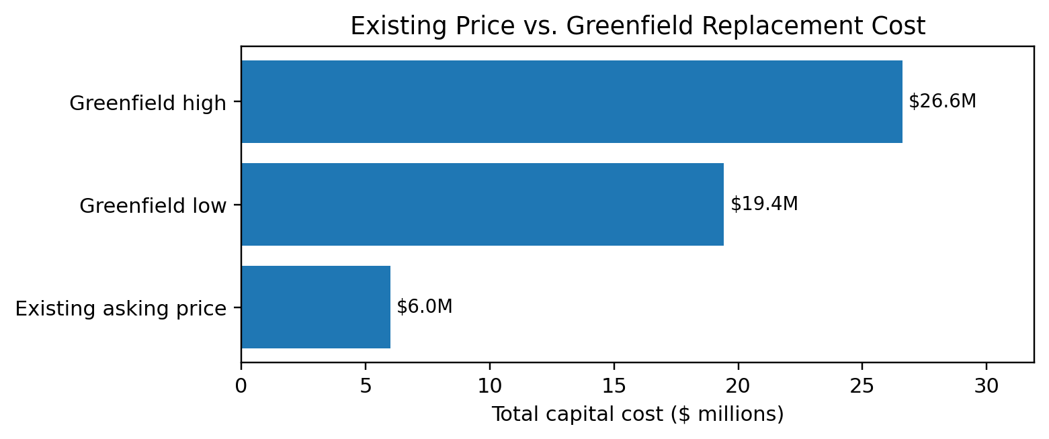

1. Subject Property Snapshot
The estimate uses the uploaded leasing brochure and parcel report as the basis for the physical scope. Calculations use the brochure's +/-173,437 SF building size; the front page also lists total available space of +/-173,473 SF.
Item | Existing 1016 SW Evangeline data | Cost-model treatment
Building / use | +/-173,437 SF industrial warehouse / distribution facility | Used as the greenfield replacement building area.
Site | +/-12.26 acres with laydown yard and outdoor storage/staging | Replacement site assumes similar acreage, paved truck court/yard, fencing, drainage, and utilities.
Zoning / location | IL - Industrial Light; frontage on Evangeline Thruway; close to I-10 / US-90 | Assumes comparable industrial-zoned Lafayette-area site with regional logistics access.
Existing offer | $6,000,000 sale price; $5.00/SF/YR lease rate; $72,265.42/month NNN | Sale price is compared to replacement cost. Lease rate is compared to implied replacement-cost rent.
Title / ownership nuance | Brochure states property operates under a ground lease and sale includes leasehold improvements only | Greenfield fee-simple comparison includes a separate land-acquisition allowance.
Cold storage note | Brochure notes the leftmost space was formerly a cold-storage facility | Baseline estimate is dry warehouse only. Cold storage/refrigeration would require a separate, materially higher budget.

2. Greenfield Budget Estimate
This is a planning-level replacement-cost model for a standard dry warehouse/distribution facility. It is intended to frame a buy/lease-versus-build decision, not to replace a contractor estimate, civil takeoff, environmental report, or appraisal.
Cost bucket | Low case | High case | Basis / notes
Building + site construction | $14,742,145 ($85/SF) | $19,078,070 ($110/SF) | Uses a $85-$110/SF planning range for a large dry warehouse/distribution building with basic MEP, dock-high operations, paving/site work, and normal industrial fit-out.
Soft costs, design, permits, contingency, escalation | $3,685,536 (+25%) | $5,723,421 (+30%) | Covers architecture/engineering, surveys, permits, testing, legal/insurance, project management, contingency, and pricing uncertainty.
Total project cost excluding land | $18,427,681 | $24,801,491 | Equals roughly $106.25/SF to $143.00/SF of building area before land.
Land acquisition allowance | $1,000,000 | $1,800,000 | Local industrial land indicators support a midpoint around $1,462,593 for 12.26 acres using an approximately $119,298/acre market reference; the parcel report's land-market value is lower, so the range is intentionally broad.
Total all-in greenfield cost | $19,427,681 | $26,601,491 | Roughly $112.02/SF to $153.38/SF of building area.

3. Existing Offer vs. Greenfield Replacement
Metric | Existing property / offer | Greenfield replacement | Implication
Capital outlay | $6.0M asking price | $19,427,681-$26,601,491 including land | Greenfield is roughly 3.2x-4.4x the stated asking price.
Price per building SF | $34.59/SF | $112.02/SF-$153.38/SF | Existing basis is far below replacement cost, but leasehold/ground-lease terms must be valued separately.
Land / control | Sale appears to include leasehold improvements only; land owned separately | Assumes fee-simple land acquisition | The main diligence item is the ground lease: term, rent, renewal rights, assignment rights, and reversion risk.
Occupancy cost | $5.00/SF/YR NNN; $72,265.42/month | Replacement-cost rent likely $8.96-$13.80/SF/YR NNN at 8%-9% yield on cost | The quoted lease rate is materially below the rent a new build would typically need to justify development capital.
Speed to market | Immediate or near-term occupancy subject to repairs and lease terms | Likely entitlement/design/construction timeline | Existing asset may save 12-24+ months versus greenfield development depending on permitting and site readiness.
Functional quality | Older existing building with large yard; some areas formerly cold storage | New building can be designed for clear height, truck court, dock count, ESFR, LED, power, and trailer circulation | Greenfield may have a higher functional ceiling, but at a much higher capital basis.

4. Sensitivity: What Moves the Number
The model is most sensitive to site work, clear-height / structural system, dock and truck-court design, office percentage, fire protection, cold-storage requirements, and offsite utility upgrades.
Construction basis | Soft / contingency load | Total excl. land | Total incl. midpoint land | All-in $/SF
$85/SF construction | 25% soft/cont. | $18,427,681 | $19,890,275 | $114.68/SF
$95/SF construction | 25% soft/cont. | $20,595,644 | $22,058,237 | $127.18/SF
$110/SF construction | 30% soft/cont. | $24,801,491 | $26,264,084 | $151.43/SF
$130/SF construction | 30% soft/cont. | $29,310,853 | $30,773,446 | $177.43/SF
Cold-storage scenario | Separate specialty budget | Not included | Can materially exceed baseline | See exclusions

5. Key Diligence Before Relying on the Estimate
• Ground lease economics: base rent, escalations, remaining term, renewals, assignment, lender protections, casualty/condemnation, and what happens to improvements at expiration.
• Building condition: roof, slab, columns/steel, dock equipment, fire sprinkler, electrical service, office HVAC, plumbing, and any former cold-storage systems or penetrations.
• Civil/site: stormwater capacity, detention requirements, truck court condition, paving replacement, fencing/security, utilities, offsite improvements, and access/traffic review.
• Environmental: Phase I ESA, railroad-adjacent issues, historical use, vapor, soil/groundwater, asbestos/lead paint, and any remediation obligations.
• Operational fit: clear height, dock count, trailer/car parking, laydown intensity, floor flatness, power demand, office ratio, and whether cold storage or automation is actually required.

6. Exclusions and Caveats
• No contractor bids, civil takeoff, geotechnical report, survey, environmental assessment, title review, or lease review were available.
• Baseline excludes refrigerated/cold-storage fit-out, rack systems, conveyors, automation/robotics, tenant equipment, rail spur work, significant offsite utility upgrades, extraordinary soil remediation, and financing costs.
• The estimate assumes a standard dry industrial warehouse/distribution facility. New modern specs could raise the range, especially with higher clear heights, ESFR, extensive trailer parking, heavy power, or a larger office component.
• The existing $6.0M price is not equivalent to fee-simple ownership if the land remains subject to a ground lease. The ground-lease present value and reversion risk should be modeled before purchase.

7. Sources Used
• Uploaded Lease Brochure, May 2026: sale price, lease rate, building size, site size, zoning, ground-lease statement, property photos, and flood/zoning pages.
• Uploaded Lafayette Parish Beacon parcel report dated May 30, 2026: parcel ID, owner, assessment/land value, deed units, and sales history visible in the uploaded property report.
• Cushman & Wakefield, 2025 Industrial Construction Cost Guide: reported 2025 average ground-up industrial costs of approximately $139/SF for small projects, $85/SF for medium warehouses, and $77/SF for large projects.
• CBRE, Warehouse & Distribution Construction Cost Trends 2023-2024: industrial construction costs increased sharply after 2019; CBRE also notes building shell, site work, and office TI as major cost categories and that site-work estimates vary materially by market.
• Brown Integrated Logistics, 2026 warehouse cost guide: broad 2026 national warehouse cost ranges; large distribution centers commonly cited at roughly $70-$110/SF; hard costs often 70%-80% and soft costs 20%-30% of budget; cold storage/refrigerated warehousing can be much higher.
• LandSearch Lafayette/Lafayette Parish industrial land listings as of 2026: average industrial land asking costs around $116k-$119k per acre, used only as a rough land-acquisition cross-check.
• Rider Levett Bucknall Q1 2026 Construction Cost Report: construction cost increases have stabilized but remain upward, with RLB's index up about 4.4% in Q1 2026.

Recommended Next Step
Use the greenfield estimate as the replacement-cost ceiling, then diligence the leasehold risk. On pure cost basis, the existing improvement purchase looks deeply below replacement cost. The question is whether ground-lease economics, building-condition capex, environmental/site liabilities, and functional obsolescence offset that apparent discount.

